Reference Material
This certificate is designed in accordance with ISO 17034 and ISO Guide 31. This reference material (RM) was designed,produced
and verified in accordance with ISO/IEC 17025, ISO 17034 and a registered quality management system ISO 9001.
Product Name 7 Synthetic Pigment Mix in Water,1000µg/mL

Part Number
Expiry Date
B64280
Lot Number
Storage
Y21A13Y180543
2022-Sep-07
(20±5)°C,Dark
CERTIFIED
Component
No.
Peak
Sequence
Concentration
(µg/mL)
Uncertainty
(%)
Component
CAS No.

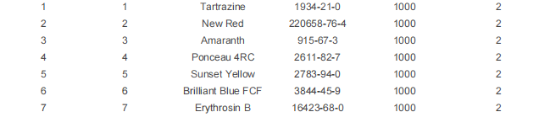


Intended Use
This RM is intended for use in a laboratory as a calibration and quality control standard or in method development for analytical
techniques.
Uncertainty
The certified value(s) and uncertainty(ies) are determined in accordance with ISO 17034 with an 95% confidence level (k=2).
Uncertainty is based on the Total Combined Uncertainty, including uncertainties of preparation, purity of neat materials,
homogeneity, stability testing.
Traceability
The balances used for gravimetric measurements are calibrated with weights traceable to the national standards. The calibration of
the balances is verified annually by an external accredited calibration service. This analysis method has been verified using an
approach consistent with ISO 17034:2016 & ISO 17025:2017.
Homogeneity
Random replicate samples of the final packaged RM have been analysed to prove homogeneity consistent with ISO 17034.
Storage

The RM should be stored in the original sealed bottle at the indicated temperature.
CERTIFICATE
-
ON
QC
SIGNATURE
RM Release




